Understanding Homework Feedback

After every homework assignment is graded, you will receive a “feedback.html” file for that assignment, which you will find attached to your T-Square assignment (where you submitted the assignment).

Every feedback file will have a similar header that contains the homework number and description, your name, and a table with a breakdown of the points for each problem on the homework.

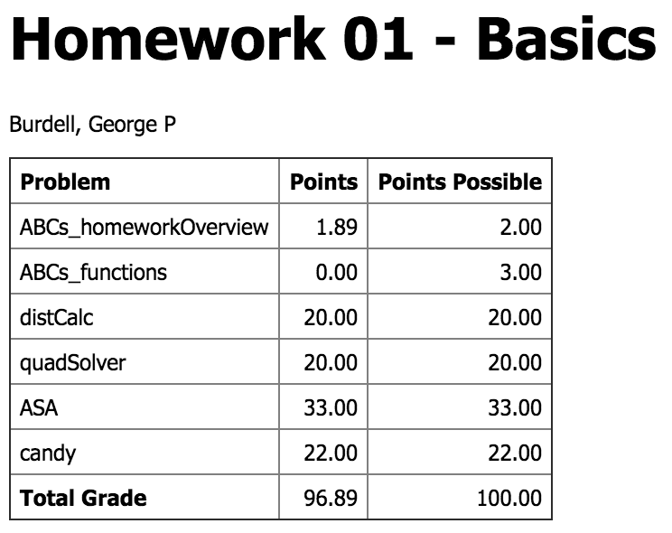

For each problem, there will be at least one test case. Each test case will be given to you.

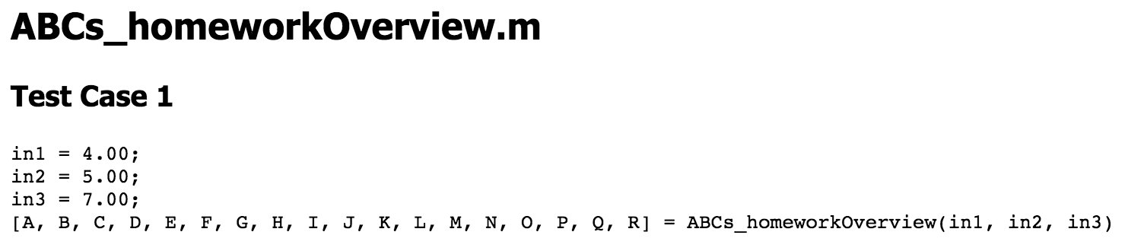

Following the test case will be a list of the output variables for that test case with either a “PASS” or a “FAIL” depending on whether or not your output for that test case matches the solution output.

# Incorrect Output

If one of your outputs is incorrect, you will see something like the image below. For each variable that is incorrect, you will see the “Function Value”, which is the value from your function, and the “Solution Value”, which is the value from the solution file.

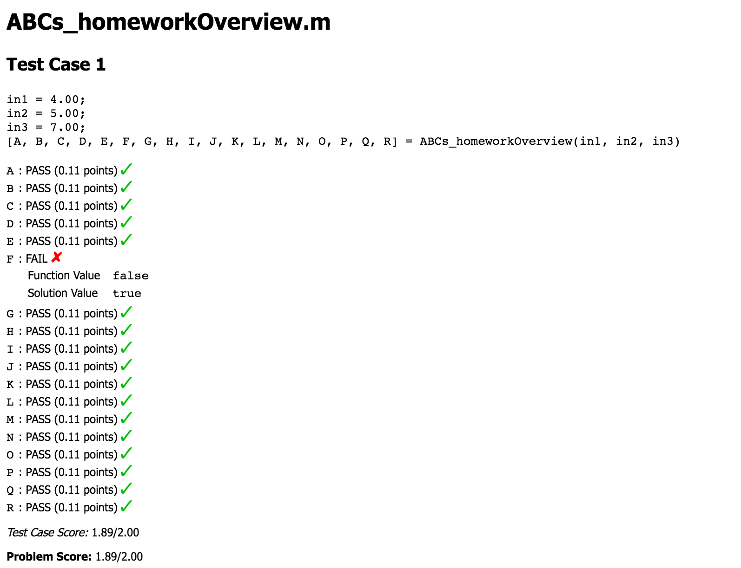

# File Does Not Exist

If you see this message for one of your problems, it means that you either did not submit the file or submitted the file with the wrong name.

